**Twilio API**

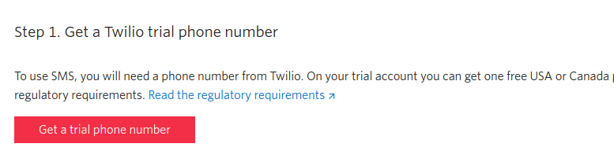

Get a free number to make message from.

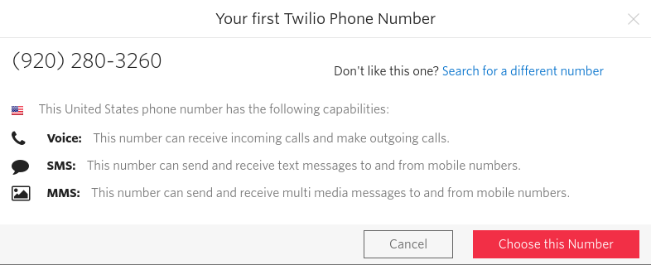

They will provide a number → we can choose a different number

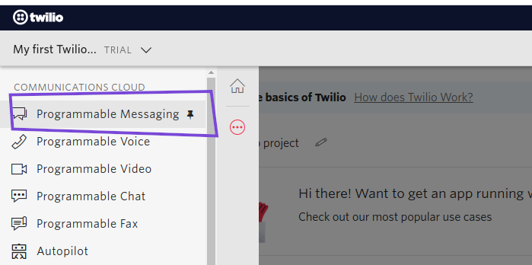

Programmable messaging is the way to message to a phone number

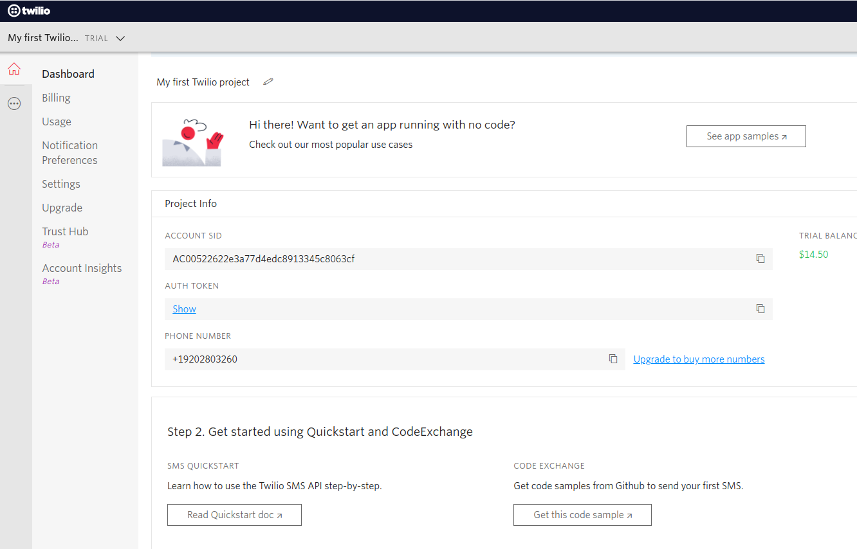

Here we can get all the credentials

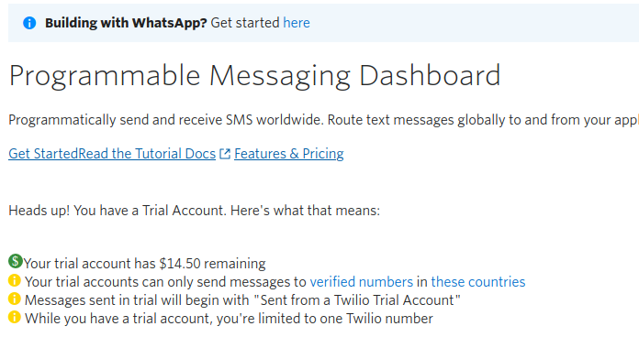

They will give us little balance to send message

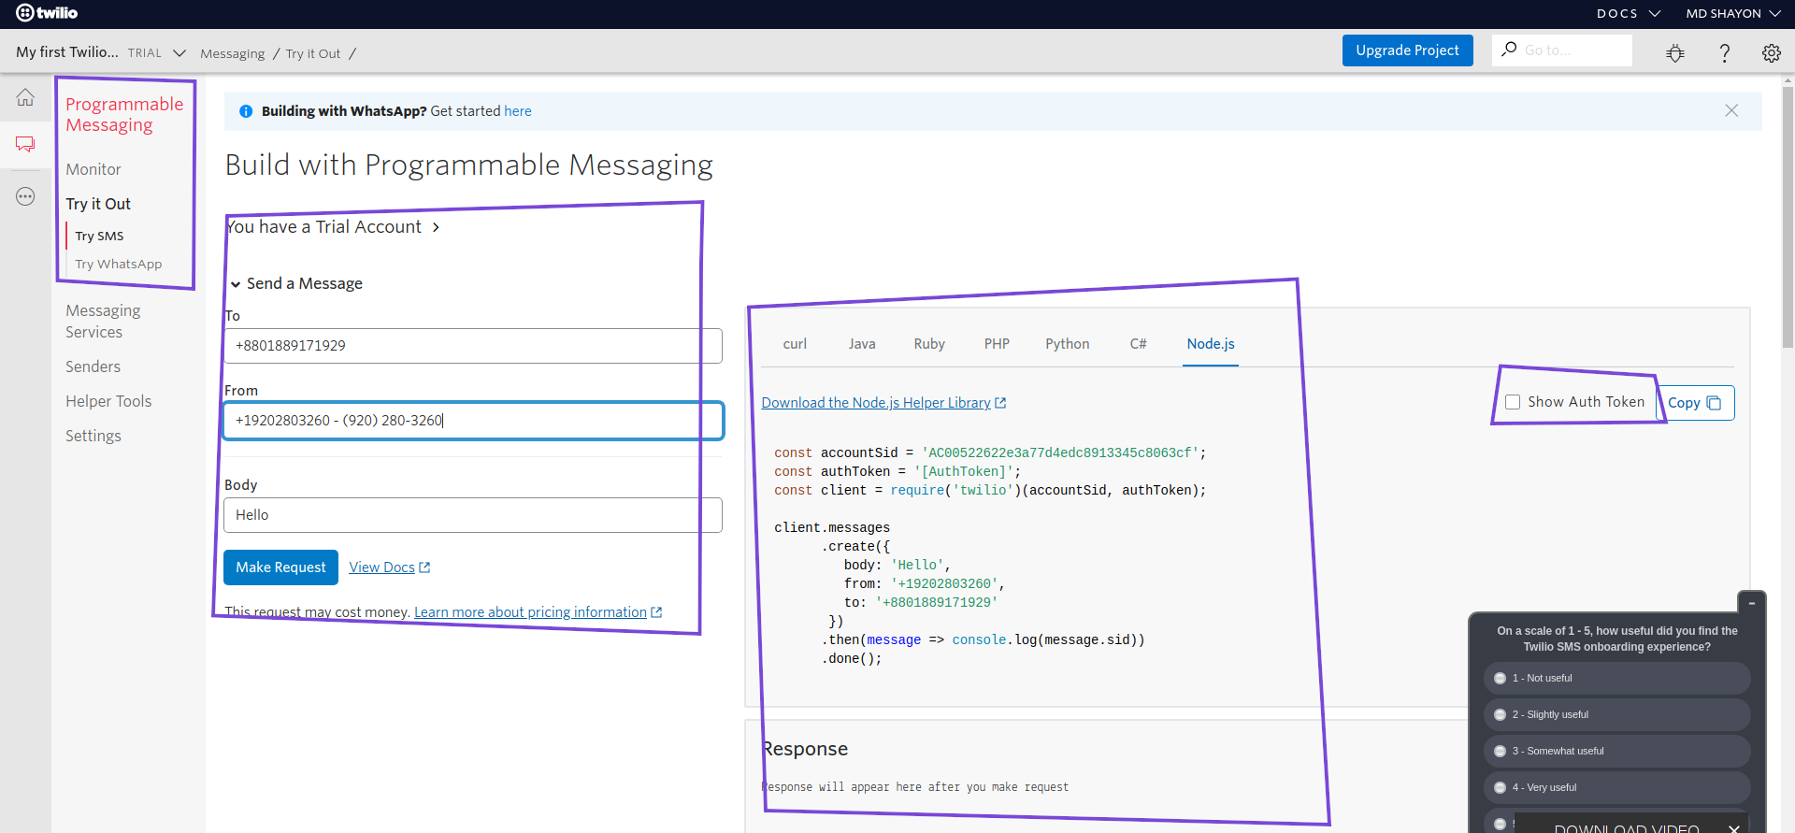

Programmable messaging → make a request to send message → we can use curl to send request (curl easy)

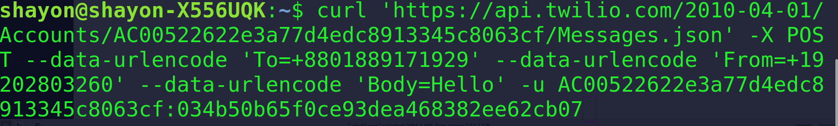

Making a post request using curl in terminal

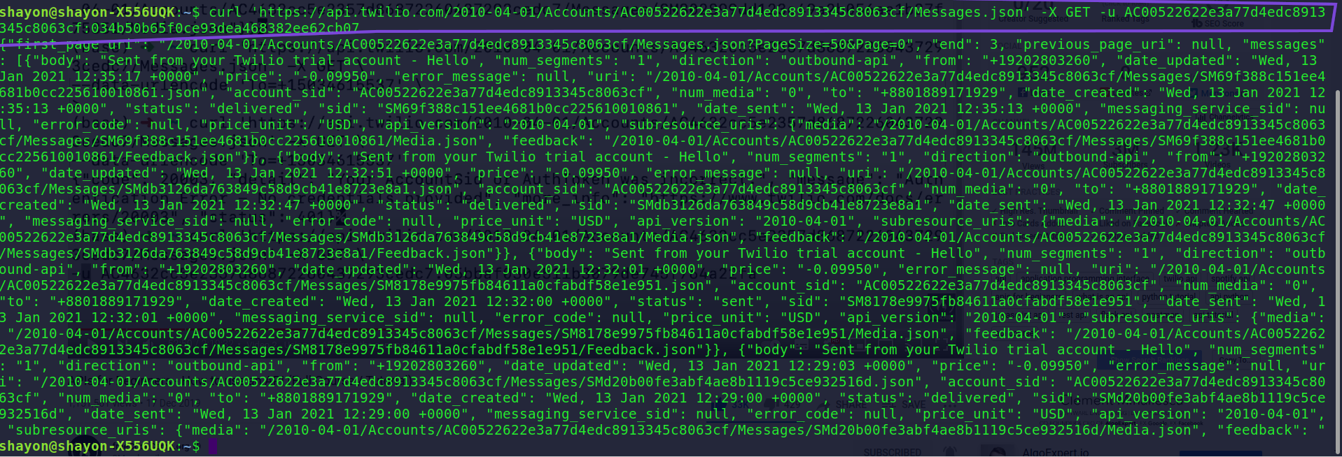

Sending a get request using curl in terminal and it’s responding perfectly

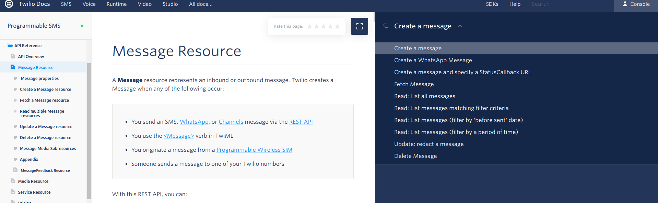

Search for **twilio message resource doc** and get the request information

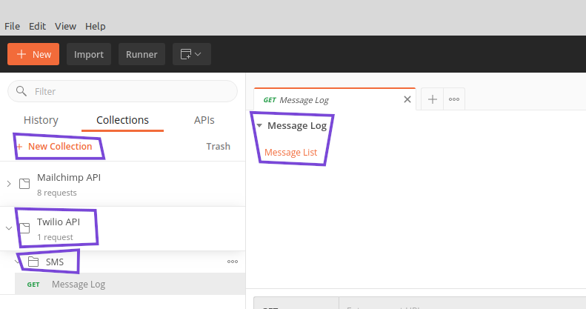

open postman → Create a collection where we can save all of our request → Inside collection we can create a folder → inside folder we can create request where we can set name and descriptions → Description allow us to write markdown text

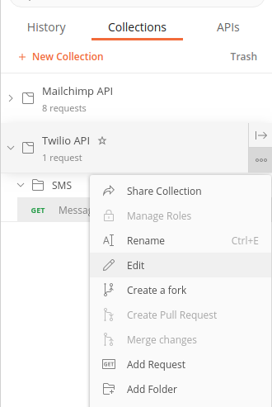

We can edit name and descriptions